1. 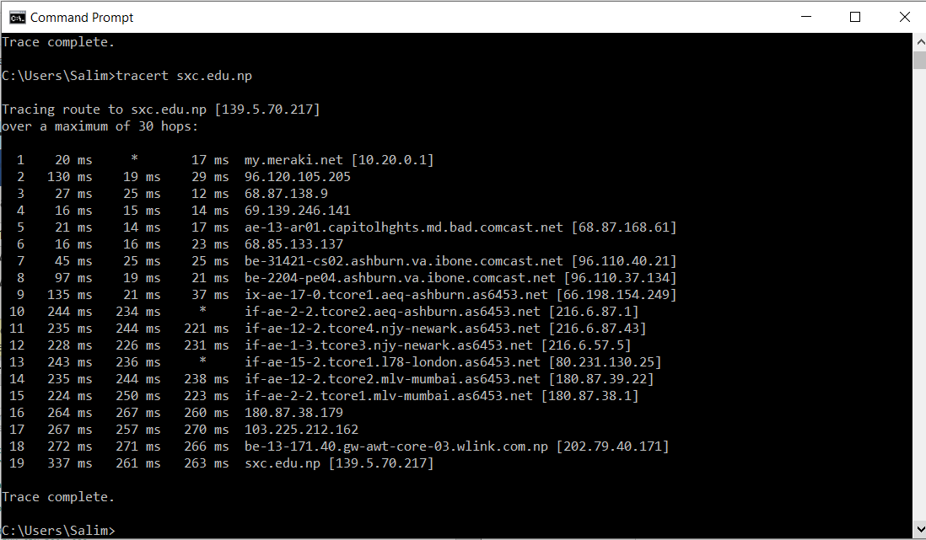

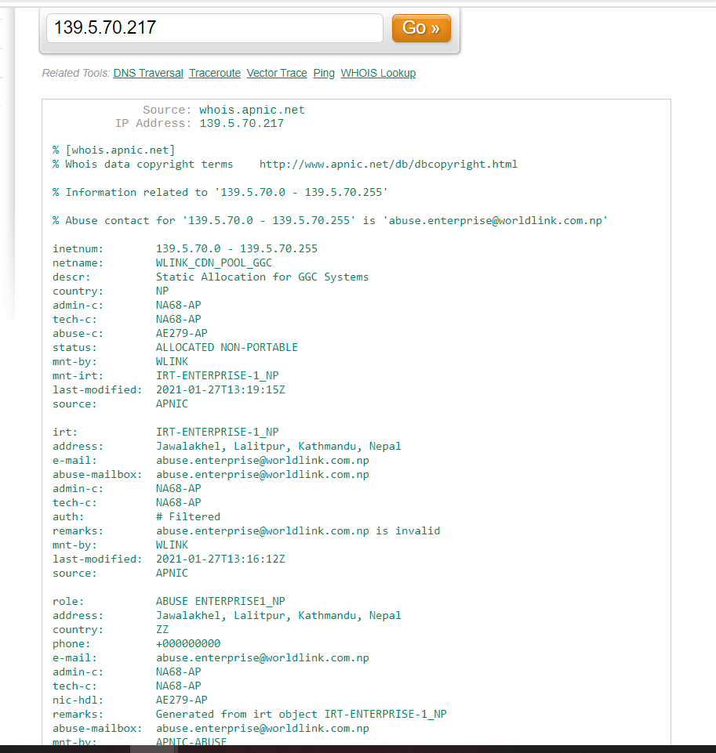

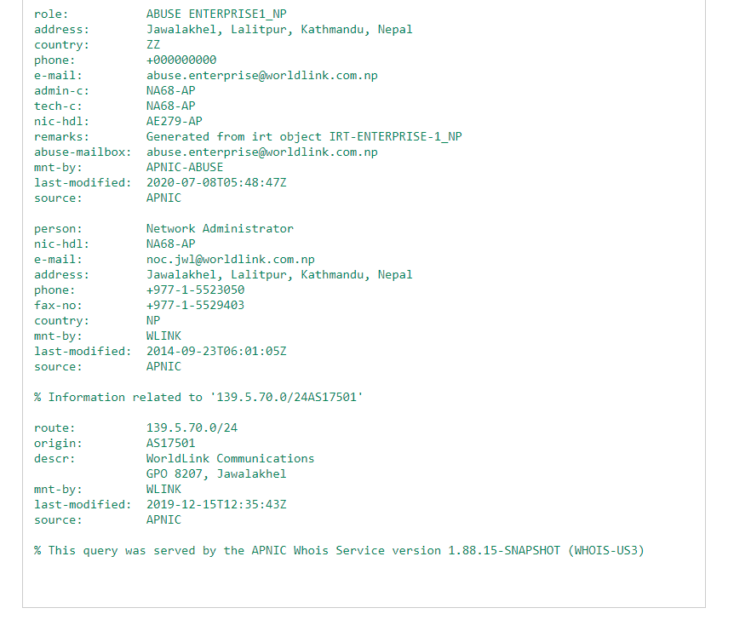

3.

|  |  |  |  |
| --- | --- | --- | --- |
| HOP Count | IP Address | Organization (IP Owner) | Location (US state)/Country |
| 1 | [10.20.0.1] | IANA – Internet Assigned Numbers Authority | 12025 Waterfront Drive  Suite 300Los Angeles, CA, USA |
| 2 | [139.5.70.217] | WLINK_CDN_POOL_GGC | Jawalakhel, Lalitpur, Kathmandu, Nepal |
|  |  |  |  |
| 3 | 96120.105.205 | DC-CDM-14 | Mt Laurel, NJ |
| 4 | 69.139.246.141 | COMCAST-44 | Mt Laurel, NJ |
| 5 | 68.87.168.61 | COMCAST-3 | Mt Laurel, NJ |
| 6 | 68.85.133.137 | JUMPSTART-2 | Mt Laurel, NJ |
| 7 | 96.110.40.21 | CABLE-1 | Mt Laurel, NJ |
| 8 | 96.110.37.134 | CABLE-1 | Mt Laurel, NJ |
| 9 | 66.198.154.249 | ASHBURN-AEQ-TATAC | ASHBURN, VA |
| 10 | 216.6.87.1 | ASHBURN-AEQ-TATAC | ASHBURN, VA |
| 11 | 216.6.87.43 | ASHBURN-AEQ-TATAC | ASHBURN, VA |
| 12 | 216.6.57.5 | NJYMC3-TATAC | NEWJERSEY, NJ |
| 13 | 80.231.130.25 | Access denied | Access denied |
| 14 | 180.87.39.22 | MLV-TCORE2-TATAC | India |
| 15 | 180.87.38.1 | MLV-TCORE2-TATAC | India |
| 16 | 180.87.38.179 | MLV-TCORE1-TATAC | India |
| 17 | 103.225.212.162 | INTERAPTUSLIMITED-HK | HK |
| 18 | 202.79.40.171 | WLINK_STATIC_P2P_ROUTER_NET1 | Nepal |
| 19 | 139.5.70.217 | WLINK_CDN_POOL_GGC | Nepal |